From the Ec2 dashboard -> click instance -> click launch instances

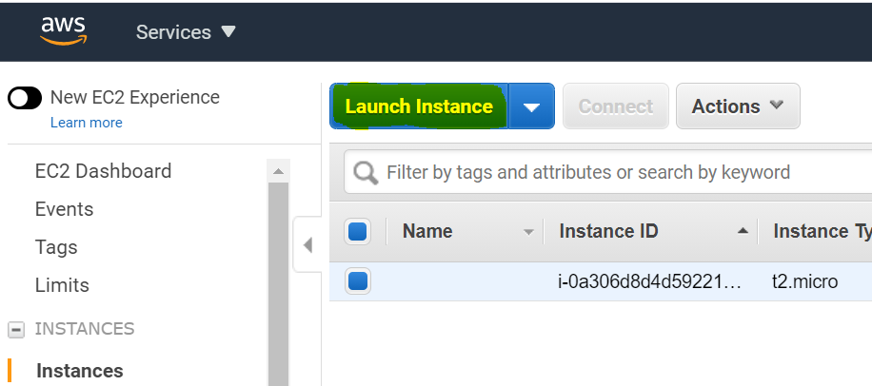

Choose the AMI images

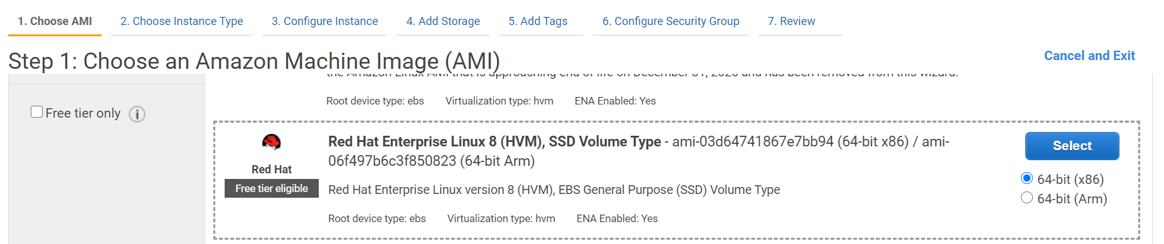

Choose the instance type

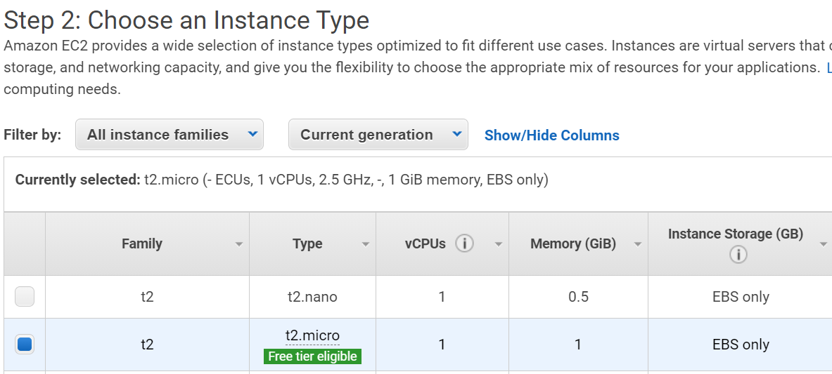

Configure the instance if required or else click add storage.

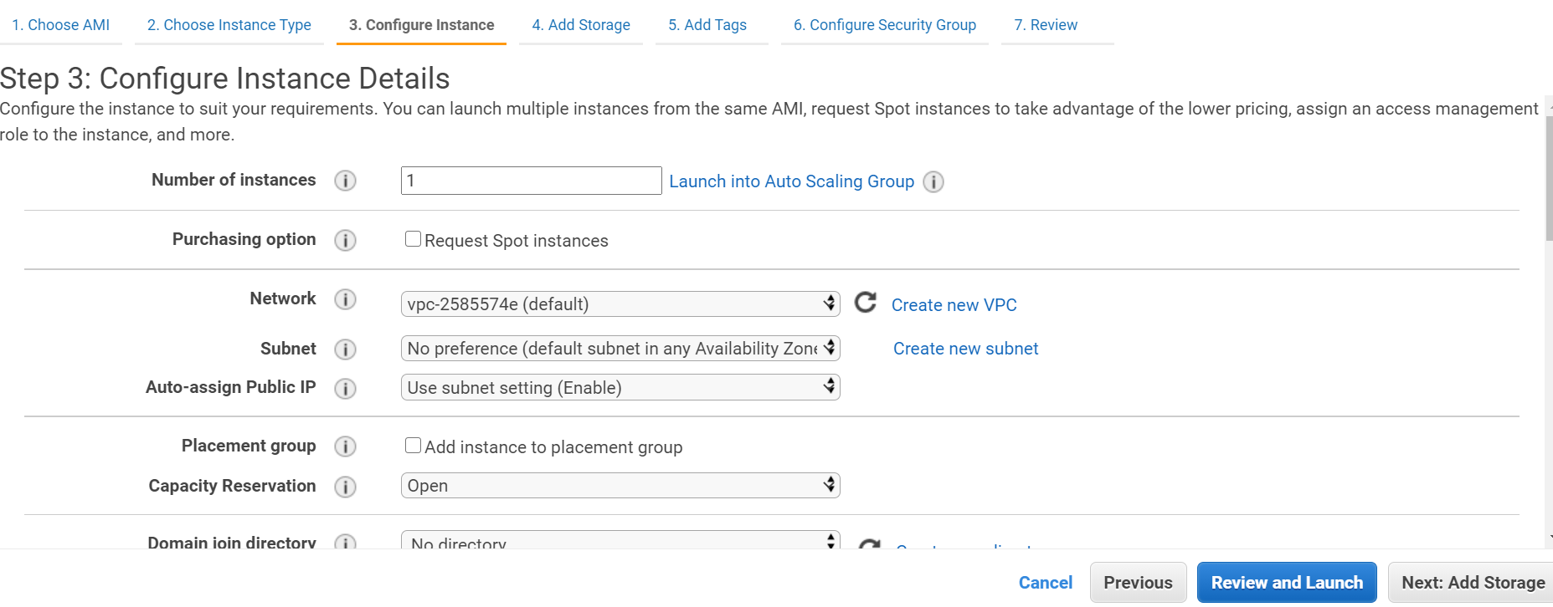

Add the storage

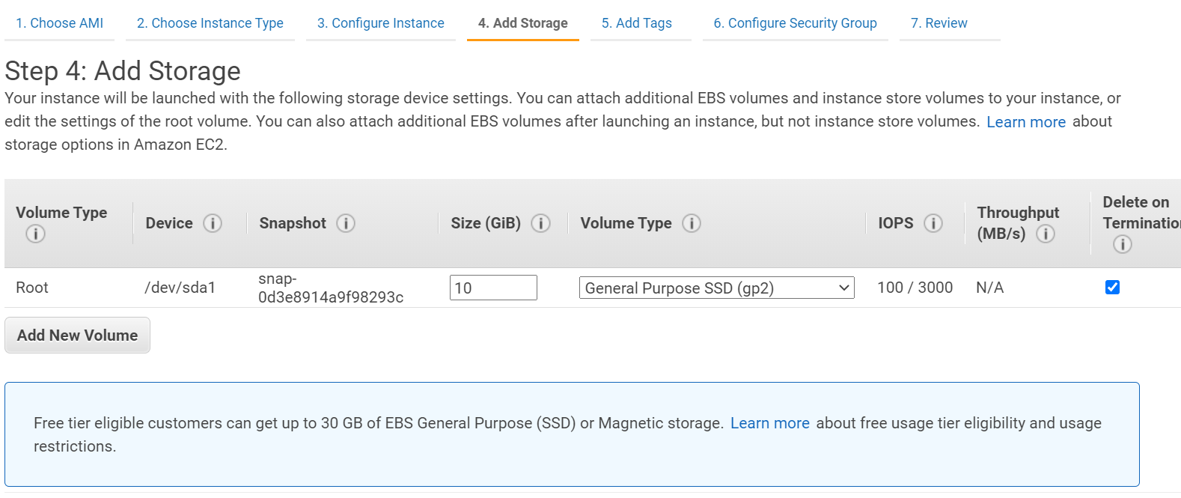

Add tags :

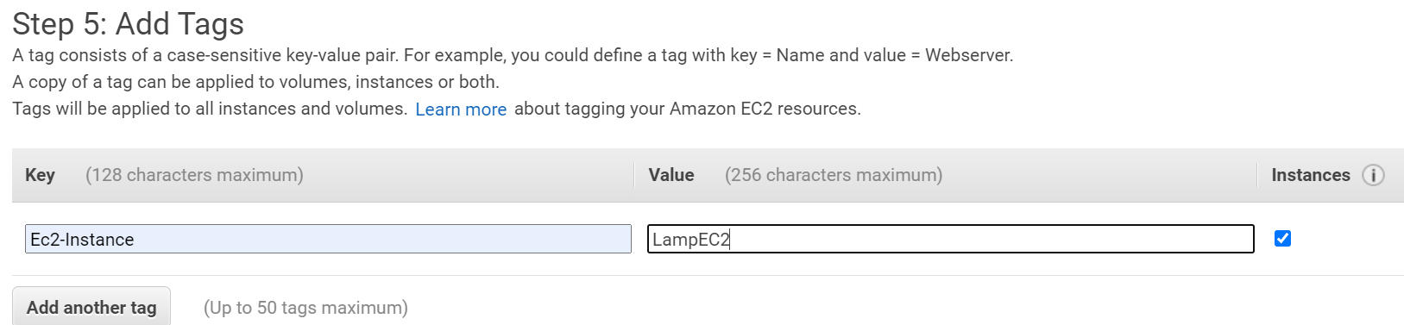

Configure security groups:

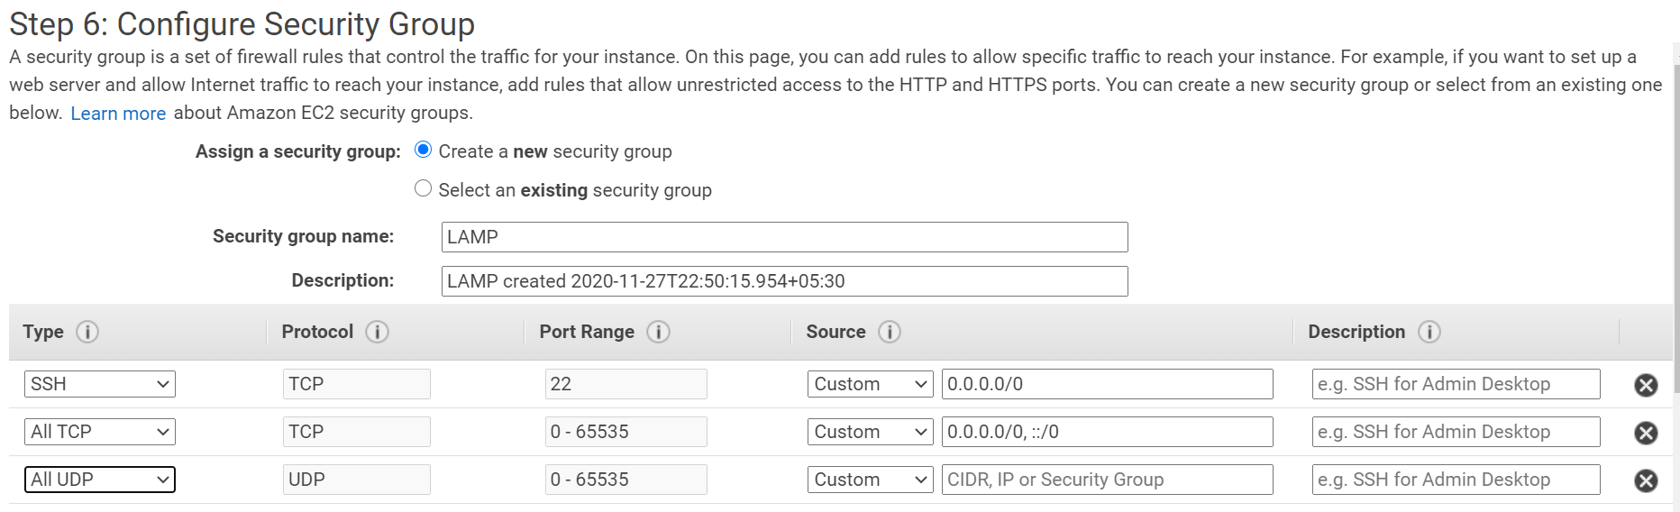

Finally review and launch the instance :

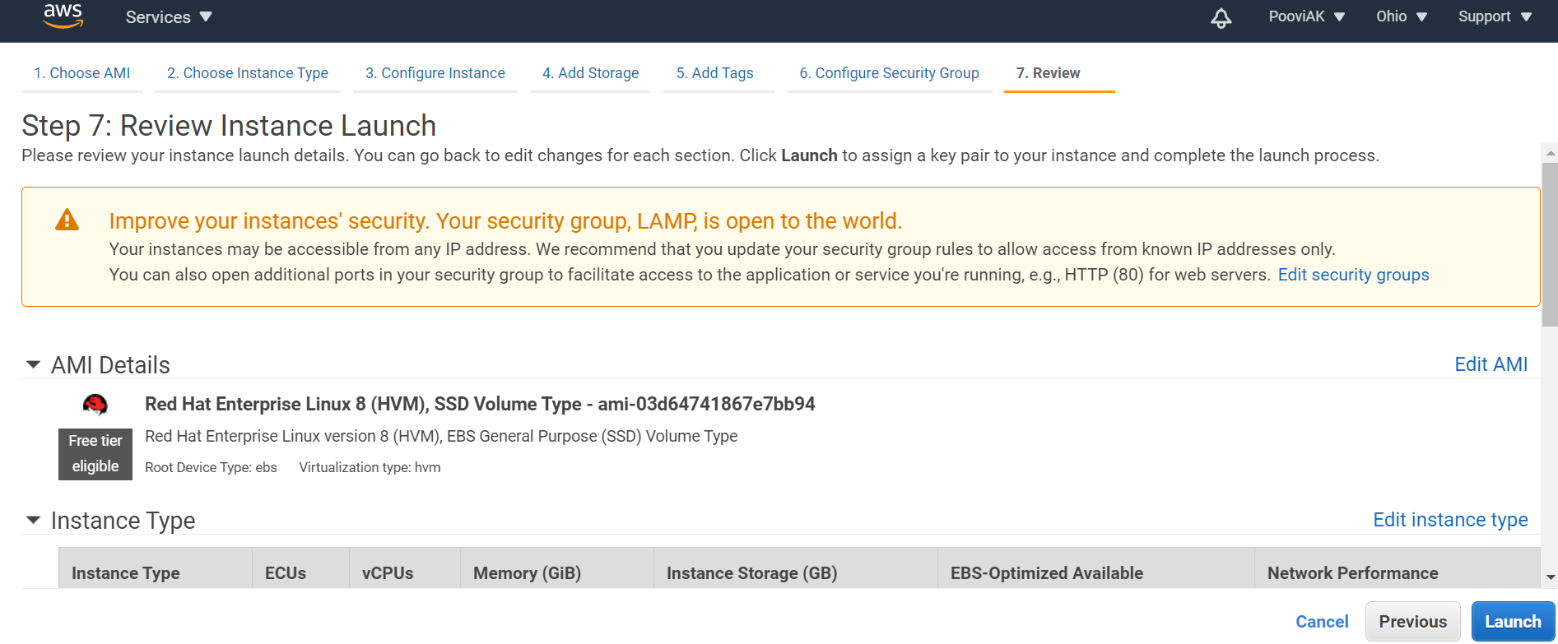

Create and download the keypair and launch the instance:

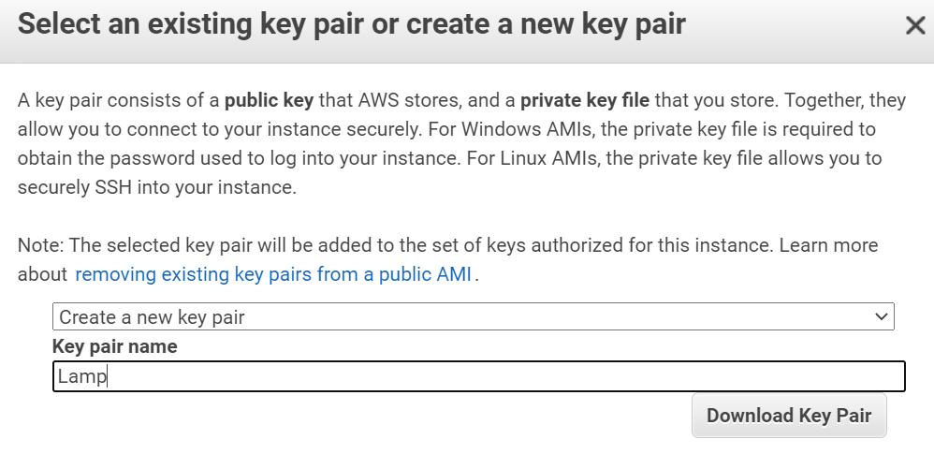

Instance created successfully:

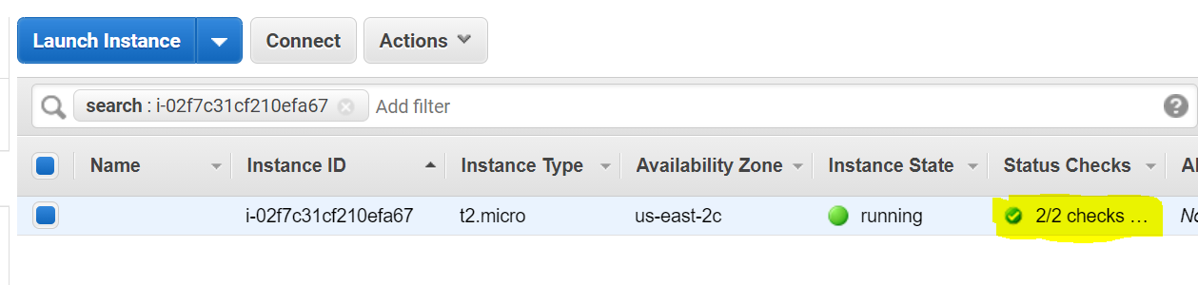

Launch the instance via putty before that convert the keypair pem file into ppk format using puttygen:

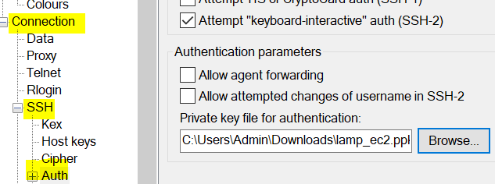

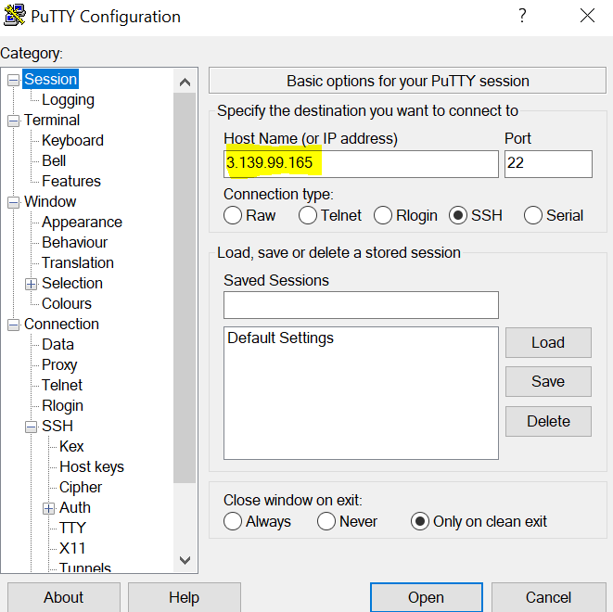

Login with default user ec2-user

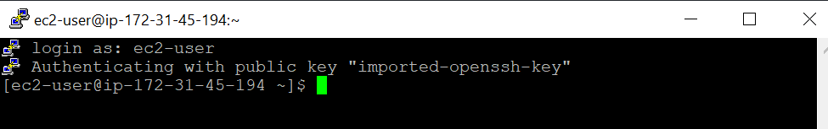

Install and configure apache:

